Minor Capital Works Fund –Round 2 - 2021 – Program Guidelines – Page 1

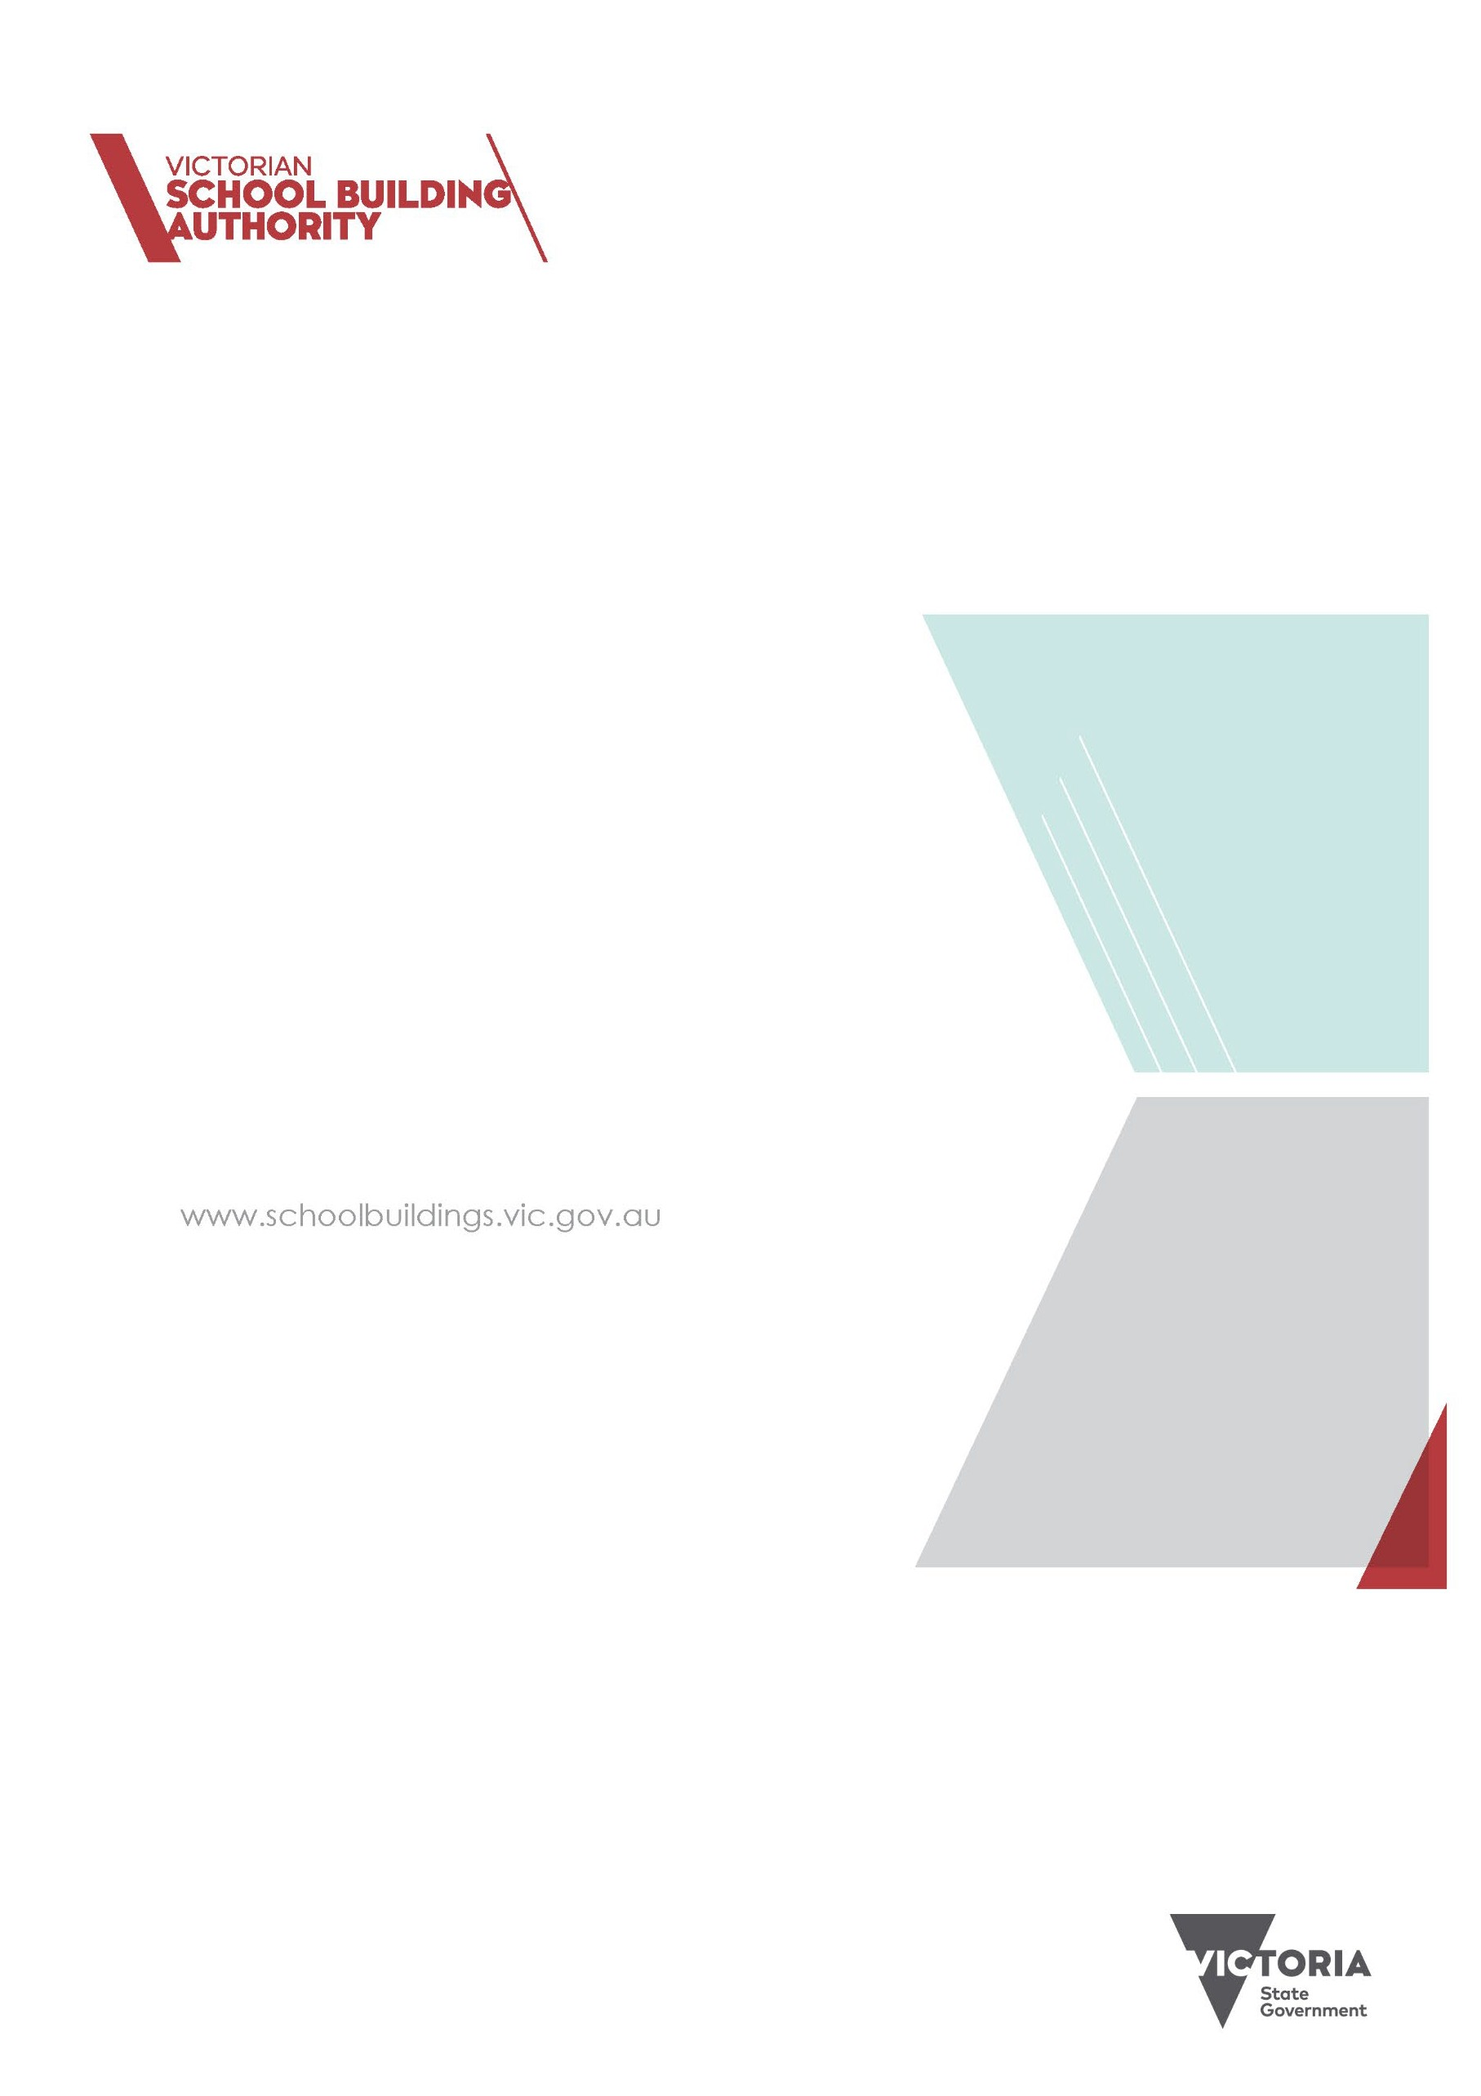

SCHOOL SHADE SAILS FUND

ROUND 1 - 2021 PROGRAM GUIDELINES

##### Published by the

##### Victorian School Building Authority Department of Education and Training

##### Melbourne September 2021

##### © September 2021 State of Victoria (Department of Education and Training)

##### The copyright in this document is owned by the State of Victoria (Department of Education and Training), or in the case of some materials, by third parties (third party materials). No part may be reproduced by any process except in accordance with the provisions of the Copyright Act 1968, the National Education Access Licence for Early childhoods (NEALS) (see below) or with permission.

##### An educational institution situated in Australia which is not conducted for profit, or a body responsible for administering such an institution may copy and communicate the materials, other than third party materials, for the educational purposes of the institution.

##### Authorised by the Department of Education and Training 2 Treasury Place, East Melbourne, Victoria, 3002.

##### This document is also available on the internet at: [www.schoolbuildings.vic.gov.au/Pages/school-shade-sails-fund.aspx](http://www.schoolbuildings.vic.gov.au/Pages/school-shade-sails-fund.aspx)

CONTENTS

1. INTRODUCTION 4

2. THE FUND 4

3. ELIGIBILITY CRITERIA 4

4. FUNDING 5

5. REGISTRATION INFORMATION 5

6. LODGING REGISTRATIONS 5

7. ASSESSMENT 6

8. DELIVERY 6

9. AQUITTAL 7

10. PRIVACY 7

11. DECLARATION 7

12. RESOURCES 8

13. REQUIRED INFORMATION CHECKLIST 9

14. PROJECT EXAMPLES 9

# INTRODUCTION

As students return to school on-site under the Roadmap to Deliver the National Plan, schools are required to increase fresh air flow into indoor spaces whenever possible and to maximise the use of outdoor learning areas or environments. The School Shade Sails Fund (the Fund) provides grants to schools for shade development to facilitate outdoor learning. Schools can apply for up to $25,000 per school campus.

The aim of the Fund is to help schools maximise the use of their outdoor learning areas and environments by creating new safe and shaded outdoor learning spaces in schools to help prevent the spread of coronavirus (COVID-19).

# THE FUND

The Fund is administered by the Victorian School Building Authority (VSBA) with grants paid directly to Victorian government schools. Funding will also be available for shade sails at non-government schools. The processes for administering this funding will be established by respective sector bodies.

The projects must be school led, which means schools must deliver projects independently and comply with all policies and regulations.

Each school is eligible for a grant of up to $25,000 per campus to install new shade sail(s).

The Fund requires schools to ‘register’ for funding and provide appropriate information in the registration form, including the proposed size and location of the requested shade sail(s).

Once this information has been assessed as meeting the requirements, schools will be given approval to proceed to the delivery stage, where they are required to submit at least one quote to the VSBA for approval.

This is not a ‘competitive’ application-based Fund and there are no ‘merit’ selection criteria. Schools that meet the eligibility requirements and provide the appropriate registration information (see below), and then follow the appropriate procurement process, will receive funding.

Schools should refer to the Department’s [Shade Sails Policy](https://www2.education.vic.gov.au/pal/shade-sails/policy) found on the Policy and Advisory Library for more information on the requirements for schools to construct and manage shade sails.

Schools are encouraged to discuss their proposed project with their regional Provision and Planning team.

#### TIMELINES

Registration is a quick and simple process.

Registrations for the program are now open and close on **22 October 2021.** Registrations will be assessed on a rolling basis as they are received, and **schools are strongly encouraged to apply as soon as possible**.

Then, once your registration is approved and you are notified by VSBA, schools will need to **obtain at least one quote within four weeks**.

# ELIGIBILITY CRITERIA

If the application is unable to demonstrate compliance against ALL eligibility criteria, it may be ruled ineligible.

VSBA will contact all applicants on the outcome of their applications. Successful projects will be published on the Victorian School Building Authority website.

#### ELIGIBLE SCHOOLS AND SITES

The Fund is application-based and open to all government schools.

Each school is eligible for a grant of up to $25,000 per campus for new shade sail(s).

Shade sails should only be installed on DET land, or on land that is leased by the school or DET. Applicants must demonstrate they have permission or other authority, to install the shade sail on leased land.

Shade sails should be maintained through the school’s routine maintenance.

The required registration information must be provided – see below.

#### ELIGIBLE PROJECTS

Projects are eligible if they are:

* + Funding a new shade sail(s) (repair or replacement shades are not eligible for funding); and
  + Supporting outdoor learning (i.e., shade sails cannot go over playgrounds or play equipment)

Schools must have an appropriate space for the shade sail(s).

#### INELIGIBLE PROJECTS

Projects are ineligible if:

* + The shade sails go over playgrounds or play equipment
  + Funding is sought to repair or replace an existing shade sail
  + The shade sail does not support an outdoor learning space

#### ELIGIBLE STRUCTURES

Once the registration has been assessed as meeting the requirements, schools will be given approval to proceed to the delivery stage, where they are required to submit at least one quote to the VSBA to approve. Additional information and guidance will be provided to schools to help them with this.

Shade sails must be constructed and/or installed in accordance with the requirements outlined in the [Building Quality and Standards Handbook](https://www.education.vic.gov.au/Documents/school/principals/infrastructure/vsba-building-quality-handbook.pdf) and must be installed or constructed by a registered Victorian Building Authority (VBA) builder. (See Delivery section for further information.)

Schools do not require planning permits to construct shade sails. The VSBA recommends that schools consult with local councils and other relevant bodies where appropriate to minimise the impact on any heritage overlays.

# FUNDING

The Fund provides grants to schools for new shade sail structures.

Funding is capped at $25,000 per school campus.

Schools can co-contribute should they want a shade sail that exceeds $25,000, or multiple shade sails.

To help with planning, see the below ‘Project Examples’ section for photos and approximate costs for projects of different sizes.

#### 

# REGISTRATION INFORMATION

The online registration form is simple and easy to follow. This is what you will need to provide:

* 1. Basic details about your school and best contact for the project
  2. Information about any existing shade sails (i.e., how many and where they are located if it is not clear on your existing SAMS plan)
  3. A brief description of your proposed project (i.e., what area you would like shaded and how it will be used for outdoor learning)
  4. A marked-up SAMS plan that shows where you are planning to install the new shade sail(s) and approximate size (sqm).

# LODGING REGISTRATIONS

#### Registrations:

* + are made online through the SmartyGrants system at [www.vsba.smartygrants.com.au](http://www.vsba.smartygrants.com.au/)
  + can be changed any time until you submit the form
  + must have all sections of the form completed for registration to be considered.

To ensure that you supply all relevant information, see the ‘Required Information’ section below in these guidelines before submitting your registration.

We also recommend that you discuss your registration with your reginal Provision and Planning office before submitting.

Registrations are open and close on **22 October 2021**. Registrations will be assessed on a rolling basis as they are received, and schools are strongly encouraged to apply as soon as possible.

**Any school having any difficulty with the registration process or the timelines should contact the VSBA’s School Grants Unit:** [**school.shade.sails@education.vic.gov.au**](mailto:school.shade.sails@education.vic.gov.au) **or 1800 896 950.**

# ASSESSMENT

#### ASSESSMENT CRITERIA

Registrations will be assessed against the following assessment criteria.

|  |  |
| --- | --- |
| **ASSESSMENT CRITERIA** | |
| 1. **All requested information provided** | ✓ |
| 1. **Scope of works to create a safe and shaded outdoor learning space clearly defined** | ✓ |
| 1. **Marked-up SAMS plan clearly identifies where the new shade sail will be installed and its approximate size in square metres and verifies it’s not over a playground.** | ✓ |

#### ASSESSMENT PROCESS

The Victorian School Building Authority will:

* + assess all registrations for eligibility as per the Eligibility Criteria
  + assess all eligible registrations against the Assessment Criteria
  + Schools will be advised of the outcome of registrations via email within 5 days of submitting a completed registration form.

Once your registration has been approved, you will need to obtain a quote within **four weeks** to receive the funding.

# DELIVERY

All projects will be school led. Schools must deliver the projects independently and comply with all policies and regulations. Schools should refer to the Department’s [Shade Sails Policy](https://www2.education.vic.gov.au/pal/shade-sails/policy) found on the Policy and Advisory Library for more information.

**Once your registration is approved and you are notified by VSBA, you will need to obtain a quote within four weeks**.

If you wish to make a school contribution and the total cost of your project is over $50,000, you will need to obtain three quotes. All quotes and subsequent delivery must be from a registered Victorian Building Authority (VBA) builder with a current Australian Business Number (ABN) and evidence of Public Liability Insurance coverage.

These are the criteria that you need to consider when seeking a quote:

* Shade sail will be installed or constructed by a registered Victorian Building Authority builder with a current ABN and evidence of Public Liability Insurance coverage
* Provides high/extreme UV protection (50 SPF or higher) throughout the day and year for students and teachers
* Includes supports that are clearly visible, with rounded edges and/or padding and placed to minimise risk of collision
* Includes vertical supports that are not scalable by students, and that do not make fences scalable
* Does not impede the vision of supervisors
* Must have a minimum clearance of 3m in height
* Can withstand a variety of weather conditions and high winds
* Is located with due cognisance of existing services, such as drainage, power lines, gas, and water
* Avoids cables and guy ropes where possible

Your quote will be checked by the VSBA to ensure it meets the minimum requirements.

Funding will be provided once the VSBA is satisfied with your quote. The funding will be transferred to your school in two milestone payments as below.

|  |  |  |
| --- | --- | --- |
|  | **PAYMENT** | **DOCUMENTATION REQUIRED** |
| **MILESTONE 1** | 80% of allocated funding upon approval of documentation | * Submission of quote, approval for leased land, where applicable * Signing of a funding acceptance |
| **MILESTONE 2** | 20% of allocated funding upon approval of documentation | * Submission of the Project Acquittal Form * Payment receipt/invoice showing who the funds were paid to and when * Photographic evidence of the completed project/works * Confirmation the school SAMS plan has been updated (where relevant) |

# AQUITTAL

Schools must submit an acquittal including at least one photo of the shade sail(s), as well as payment receipt/invoice showing who the funds were paid to and when, no later than 7 days after completion of the project to progress to Payment Milestone 2.

# PRIVACY

Information you provide will be dealt with in accordance with the Public Records Act 1973 and the Privacy and Data Protection Act 2014.

# DECLARATION

At the bottom of the online application form in SmartyGrants, by submitting your application, you’ll agree to the following terms and conditions.

The school accepts the terms and conditions described in the Program Guidelines. I confirm that:

* *I am either the principal of the school where the proposed project would take place, or I have received the authority of the principal to submit this application on their behalf.*
* *the school council (and school council president) is aware of and supportive of this application.*
* *that this project would be undertaken on land owned by the Department of Education Training (DET, Victorian Government).*

I state:

* *that the information in this application and attachments is to the best of my knowledge true and correct.*
* *I will notify the VSBA of any changes to this information and any circumstances that may affect this application, including any changes to the project name, scope of works and contact details for the project.*

I warrant that:

* *I have obtained or will obtain (where necessary) all permits (including building permits), approvals and authorities necessary and required by law to undertake the works proposed.*

I consent to the VSBA:

* *referring this application to other areas within the DET for advice on alignment with program principles, compliance with regulatory requirements, and potential risks and issues.*
* *referring this application to external experts or other government departments for assessment, reporting, advice, comment or for discussions regarding alternative or collaborative grant funding opportunities.*

I understand:

* *that personal information collected through this application will be managed in accordance with DET* [*privacy policies.*](http://www.education.vic.gov.au/Pages/privacy.aspx)
* *the VSBA is subject to the Freedom of Information Act 1982 and that if a Freedom of Information request is made, the VSBA will consult with the applicant before any decision is made to release the application or supporting documentation.*
* *this is an application only and may not necessarily result in funding approval.*
* *submitting this application, I am agreeing to all terms and conditions set out in the Guidelines and in particular:*
  + *hold milestone events on request from the Department of Education and Training*
  + *that no additional state funding will be allocated to the proposed project and if additional costs rise, they must be met by the applicant.*
  + *that my school has not entered into and will not enter into a construction contract for any works proposed in this application prior to being informed of the application outcome.*
  + *the project will be completed by the end of June 2022.*

I understand and agree with the Terms and Conditions as outlined above.

# RESOURCES

The following links are provided to assist with applications

[Victorian School Building Authority website](https://www.schoolbuildings.vic.gov.au/Pages/home.aspx) [Shade Sails Policy](https://www2.education.vic.gov.au/pal/shade-sails/policy)

[Building Quality and Standards Handbook](https://www.education.vic.gov.au/Documents/school/principals/infrastructure/vsba-building-quality-handbook.pdf)

CONTACT US

If you require further information about the program or eligible projects, or need assistance with your application, please contact the VSBA School Grants Unit:

Email: [school.shade.sails@education.vic.gov.au](mailto:school.shade.sails@education.vic.gov.au)

Phone: 1800 896 950

# REQUIRED INFORMATION CHECKLIST

You **MUST** supply the following:

|  |  |
| --- | --- |
| **REGISTRATION CHECKLIST** | |
| **BASIC SCHOOL INFORMATION** | * Details of the school contact person for the project * School name, address, and contact details |
| **INFORMATION ABOUT EXISTING SHADE SAIL(S)** | * Details around any existing shade sails, including how many are currently at the school, approximate size (in sqm) and where they are located. If the existing shade sails are not identified in your current SAMS plan, you will need to mark them up. |
| **PROJECT DESCRIPTION** | * A short description of your proposed project (i.e., what area you would like shaded and why) * If applicable, demonstrate that you have permission to install a shade sail on the leased site if the site is not owned by DET (if available, this should be demonstrated through a letter of approval/support) |
| **PROJECT LOCATION** | * A site (SAMS) plan marked up showing where on your school site the project will take place and how the project will change the site (e.g. an arrow pointing to where the shade sail will be built). You can find the SAMS plan for your school at: <https://www.eduweb.vic.gov.au/SchoolFacilitiesProfile/SFPW3.aspx> * Approximate size of the new shade sail (in sqm) * Shade sail is to cover an area that can be effectively used as an outdoor learning space, and must not be over a playground * Is located with due cognisance of existing services, such as drainage, power lines, gas, and water * Avoids cables and guy ropes where possible (however, if required, these must be located in garden areas and provide marking and padded protection) * If your school is on a constrained site and the shade sail will cover any part of an existing playground or play equipment, you must be able to demonstrate how the area will be used for outdoor learning |

# PROJECT EXAMPLES

All costing requires the supply and installation to comply with the Building Quality Standards Handbook (BQSH).

Most built shade consists of two parts: the supporting structure and the primary shading material. The most common materials for built shade are metal sheets, polycarbonate, fabrics, and shade cloths. All built shade must comply with and be installed in accordance with the following Australian standards: AS 4685.1 – Playground Equipment.

At the top of the range for materials (and installation) costs will be approximately $800 per square metre. At this cost you will have a 30 square metre structure.

At the bottom of the range for materials (and installation) costs will be approximately $200 per square metre. At this cost you will have a 100 -150 square metre structure. The reason for the variance in structure size is related to the fixed costs for the posts and attachments. Shade Sail is the least costly element for construction.

|  |  |
| --- | --- |
| Bateman Architects - ONE Shade Sails | Educational Facility Shade Sails Sydney - Shade Us Now |
|  | Schools, Parks & Playgrounds |